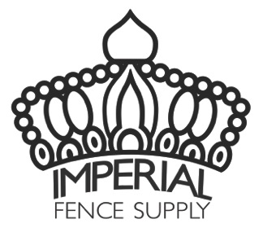

COVERAGE: Imperial Fence Supply, LLC warrants it’s Galvanized Chain Link Fabric (“Fabric”) to be free from defects in materials and workmanship and free from the development of red rust over more than 5% of the surface area of the Fabric for a period of eleven (11) years after the date of purchase by the original purchaser.

EXCLUSIONS: This limited warranty is extended to the original purchaser and is non-transferable and non-assignable to any other purchaser or subsequent owner. This limited warranty does not cover Fabric used in harsh industrial, coastal or marine environments. This limited warranty only applies to defects from normal use. This limited warranty does not cover defects from changes, damage or corrosion arising from or in connection with abnormal, improper or faulty use, installation, design, accident, alteration, neglect, abuse, abrasion, air pollutants, or damage caused by fire, flood, or other act of God. Defects in material or workmanship will be those recognized under generally accepted standards of the fencing industry.

CONDITIONS: To make a claim against this limited warranty, send a written description of the issue to Imperial Fence Supply. Please include: location of installed product, vendor, installer, and original Proof of purchase. If product is deemed defective, in its sole discretion, the original purchaser will receive a credit toward the purchase of replacement Fabric. The amount of the credit will be pro-rated based upon the unexpired portion of this eleven (11) year limited warranty from the date of purchase. The amount of the pro-rated credit will apply only to the current pricing at the time the claim. Cost of shipping, transportation, labor, removal/installation, taxes, inspection, repair or replacement or any other costs are excluded.

This warranty is only applicable to Fabric installed in The United States.